Website Evaluation
Student Name
Institution Affiliations
Date

Wright’s Law Website
The Wright’s law website is developed by Pete and Pam Wright. The couple has published several books on law and advocacy. To allow access to their material, Pete designed the law website to allow children, parents, students, advocates, and attorneys access information and content related to top law and advocacy. The image below is an overview of how the page looks like and instructions on how to navigate the website.
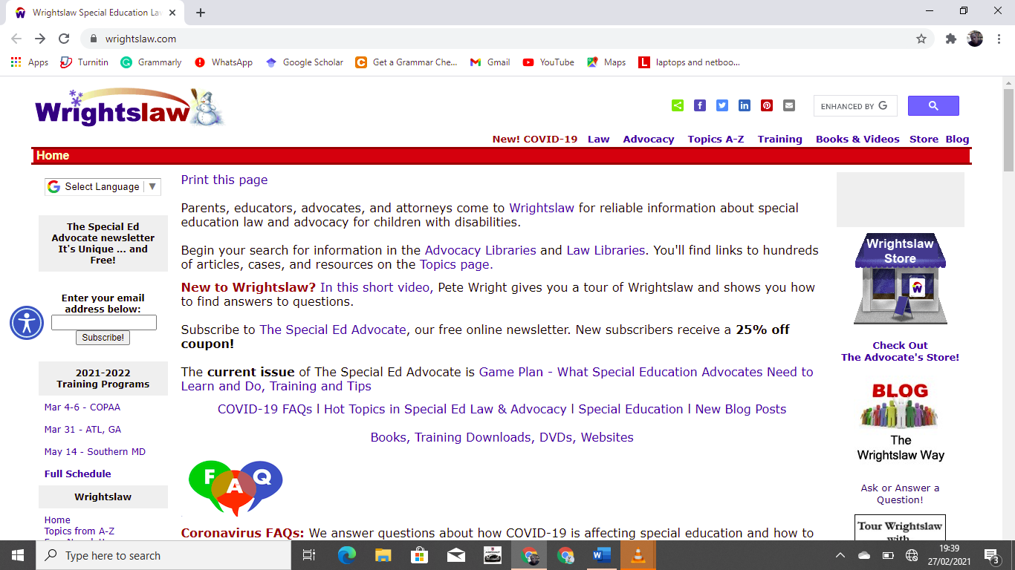
Image: Overview of Wright’s law Website.
The website has six major sections that will guide the reader to anything and everything related to law. On the left-hand side of the website, below the subscription link to the page is the ‘Training programs. The training program section contains information about pieces of training offered by Wrights Law as sessions throughout the year. Below it is the 'Advocacy library' followed by the 'Law Library'. The two are linked to statute regulations and contain links to Caselaw, Section 504, and Fed Court Complaints among others. Below is the topics section where all topics are related to law and advocacy for all levels of education. Topics such as advocacy, Bullying, damages, discrimination, eligibility, and law school clinic among many more. According to Pete, the most important section of the website is the 'Google Search Engine' located in the upper right corner. It links the website to all google searches concerning advocacy information. Furthermore, there is the Wright's Law store where visitors can get access to books and reference material. Last but not least, the yellow page for kids provides filtered content for kids. Finally, the YouTube channel is the fastest way to get information on the law without straining on reading content.
The information presented on the website is reliable. The site provides satisfactory information that students can use in their research. The feedback given by one of the users of the website indicates a positive comment on his visit to the site. Below is a prompt of the feedback. The web is very easy to use and it has been set up in a manner that information can be obtained without any difficulty. I would use the website to obtain any content related to advocacy and law.
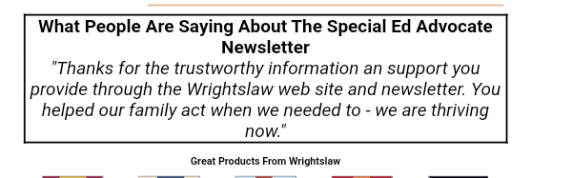
Although the government of the United States has set up public websites through the department of justice where citizens and students can obtain information related to the justice system, the Wright Law website appears to more efficient and well set up to accommodate all parties whether a law student or a general researcher including children. Most educators recommend to their students to use this website since the information is trustworthy. A recent report by William and Mary Law school indicates tremendous gratitude to Pete and Pamela Wright for providing huge inspiration, training, insight, and support to the Special Education Advocacy Clinic through their material on the website and personal visits to children living with disabilities. Pete urges students, parents, educators, advocates, and attorneys to advocate and protect the rights of disabled children. Having struggled with dyslexia, dysgraphia, and ADHD during his childhood, Pete understands the pain of children with disabilities and how they are treated by their parents, teachers, and friends.

Reference
Wright, P. (2021). Wright’s Law Special Education Law Advocacy. Accessed online at https://www.wrightslaw.com/
Wright’s Law. (2021). Wrightslaw provides answers to your questions. https://www.wrightslaw.com/video/wrightslaw.provides.answers.to.your.questions.mp4
William & Mary Law School. Wright’s Law. Accessed online at https://law.wm.edu/academics/programs/jd/electives/clinics/specialed/folder-with-content-page/index.php

